**Shopping Cart Test**

Tidak ada error yang ditemukan

Order and check out a single product using coupon

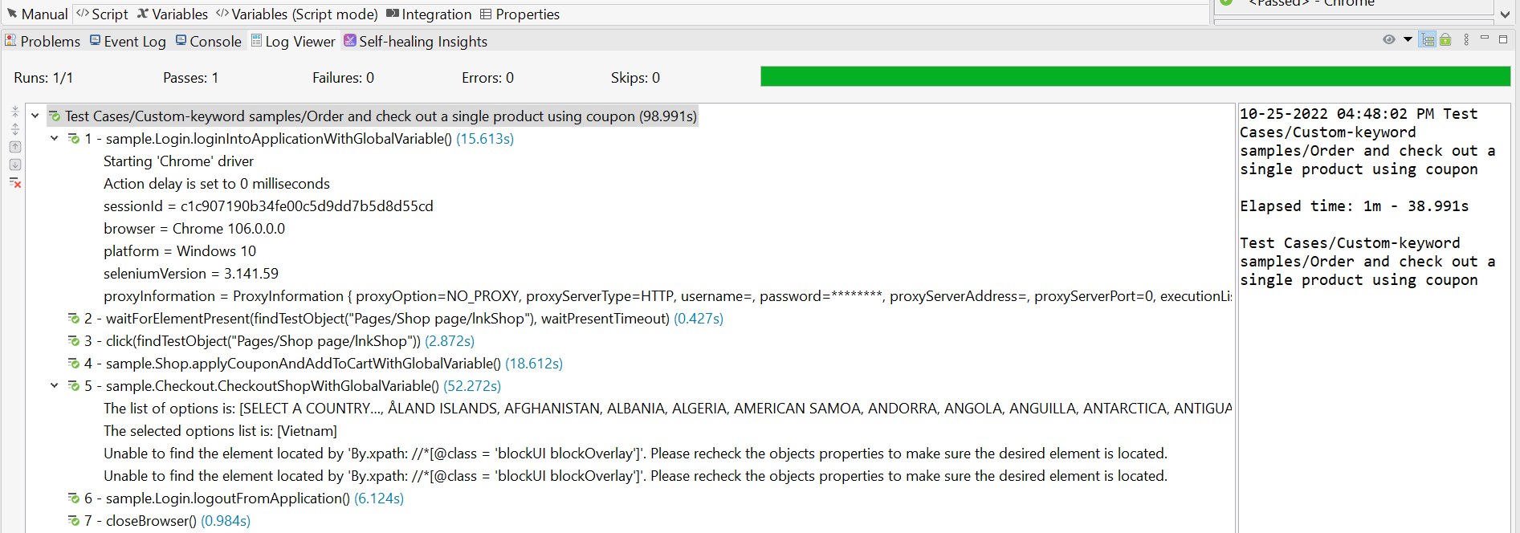

Order and check out a single product

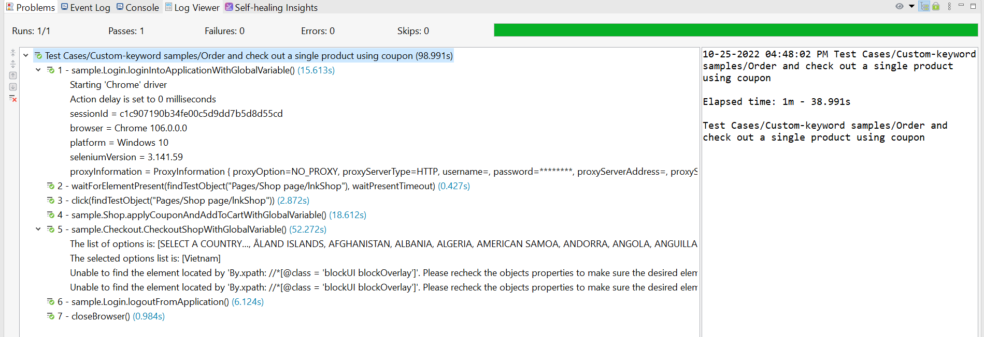

Order and check out multiple products

